**Photography and Photographers Management System**

A project report submitted in partial fulfillment of the requirement for the degree of Bachelor of Science in Computer Science and Engineering

Submitted By

**Morshedul Islam**

**CSE 01706594**

Under the supervision of

**Mohammed Morshed Rana**

Lecturer

Department of CSE

Port City International University



**Department of Computer Science and Engineering**

**Port City International University**

**Chattagram, Bangladesh.**

**19th September, 2022**

…………………….

Signature of the Supervisor

**Mrs. Manoara Begum**

**Senior Lecturer, Department of CSE**

**Port City International University**

…………………….

Signature of the Supervisor

**Mrs. Manoara Begum**

**Senior Lecturer, Department of CSE**

**Port City International University**

…………………….

Signature of the Supervisor

**Mrs. Manoara Begum**

**Senior Lecturer, Department of CSE**

**Port City International University**

**DECLARATION**

It‘s hereby declare that the whole project work has been done by us under the supervision of **Mohammed Morshed Rana**, Lecturer, Department of CSE, Port City International University. No portion of the work contained in this project has been submitted in support of any application for any other degree or qualification of this or any other university or institute of learning. I also confirm that I have only used the specified resources.

**_ _ _ _ _ _ _ _ _ _ _ _ _ _**

(Signature of the candidate)

**Morshedul Islam**

**APPROVAL**

This project titled "**Photography and Photographers Management System**", by **Morshedul Islam**, ID: **CSE 01706594**, Batch: **17 (Day)**, has been approved for summation to the Department of Computer Science and Engineering, Port City International University, in partial fulfillment of the requirement for the degree of Bachelor of Science (Engineering).

**_ _ _ _ _ _ _ _ _ _ _ _ _ _**

(Signature of Supervisor)

**Mohammed Morshed Rana**

Lecturer,

Department of Computer Science and Engineering

Port City International University

7, Nikunja Housing Society, South Khushi, Chottogram- 4202.

Chittagong, Bangladesh.

**DEDICATION**

THIS PORJECT IS DEDICATED

MY HONORABLE TEACHERS,

TO MY PARENTS

&

TO ALL OF OUR LOVED ONES

**ACKNOWLEDGEMENT**

At the beginning of all, I praise and thank Almighty Allah the most merciful and most beneficent for giving me endeavor, courage, and a great opportunity to complete the project in time.

I express my gratitude to my supervisor **Mohammed Morshed Rana** who provided me his valuable time and inspiration needed to detail this project.

I also grateful to all of my other respective teachers of my university for their advice and co-operation, who directly or indirectly helped me to stay focused for the thesis. And special thanks to my friends for their support.

**ABSTRACT**

Everybody's life is impacted by photographs since they provide us a way to remember the past and relive memorable occasions, encounters, and locations. They may shed some light on our origins and current situation. However, this holds true for many people who passed their formative years in a children's home or another institution; for these people, photos take on an even larger significance since they lack access to the types of photographs that the majority of us use for expected.

The ability to express one's own aesthetic vision through photography is only one of the numerous advantages of the medium. We take out our cameras to capture the beautiful surroundings or the aging face of a stranger. Although participants' goals may differ, they will all be motivated to produce something unique. We are artists if we take even a few minutes out of our day to make a picture, regardless of how commonplace our 9 to 5 employment is. It's a pretty lovely sensation.

We are implementing a system that will make it possible to obtain the needed photographs. Instead of simply hiring a photographer, they may make some fresh memories by snapping daily photographs. We also assist aspiring photographers by encouraging them to take part in competitions and earn prizes. They may also be hired by a client that needs a photographer for one of their many occasions or events in life.

**TABLE OF CONTENTS**

|  |  |  |
| --- | --- | --- |
|  |  | **Page No** |
| TITLE PAGE |  | I |
| DECLERATION |  | II |
| APPROVAL |  | III |
| DEDICATION |  | IV |
| ACKNOWLEDGEMENT |  | V |
| ABSTRACT |  | VI |
|  |  |  |
| **CHAPTER 1** | **INTRODUCTION** |  |
|  |  |  |
| 1.1 | Introduction | 01 |
| 1.2 | Motivation of the System | 01 |
| 1.3 | Objectives | 01 |
| 1.4 | Current System’s Limitation | 02 |
| 1.5 | Summary | 02 |
|  |  |  |
|  |  |  |
| **CHAPTER 2** | **PROJECT DESCRIPTION** |  |
|  |  |  |
| 2.1 | Advantage of Proposed System | 03 |
| 2.2 | Project Overview | 03 |
| 2.3 | System Architecture | 03 |
| 2.4 | Customer Interface | 05 |
| 2.5 | Photographer Interface | 05 |
| 2.6 | Admin Interface | 05 |
| 2.7 | Summary | 05 |
|  |  |  |
| **CHAPTER 3** | **SYSTEM DESCRIPTION** |  |
|  |  |  |
| 3.1 | Introduction | 06 |
| 3.2 | Used Tools and Platforms | 06 |
| 3.2.1 | Development Tools for Web Platform | 06 |
| 3.2.2 | Development Tools (Hardware) | 06 |
| 3.2.3 | System Requirements for Visual Studio | 06 |
| 3.2.4 | Programming Languages for Web Platform | 07 |
| 3.2.5 | Database for the System | 09 |
| 3.3 | Summary | 09 |
|  |  |  |
| **CHAPTER 4** | **SYSTEM DEVELOPMENT METHODOLOGY** |  |
|  |  |  |
| 4.1 | Necessity of Methodology | 10 |
| 4.2 | System Development Life Cycle (SDLC) | 10 |
| 4.2.1 | Analysis | 11 |
| 4.2.2 | Design | 12 |
| 4.2.3 | Implementation | 12 |
| 4.2.4 | Quality Assurance | 12 |
| 4.2.5 | Deployment | 13 |
| 4.2.6 | Support & Maintenance | 13 |
| 4.3 | Proposed System’s Model | 14 |
| 4.4 | Summary | 15 |
|  |  |  |
| **CHAPTER 5** | **SYSTEM ANALYSIS** |  |
|  |  |  |
| 5.1. | Introduction | 16 |
| 5.2 | System Analysis | 16 |
| 5.3 | Information About process | 16 |
| 5.4 | Flow chart Diagram | 16 |
| 5.4.1 | Flow chart Diagram for Customers | 17 |
| 5.4.1 | Flow chart Diagram for Photographers | 17 |
| 5.4.2 | Flow chart Diagram for Admin | 19 |
| 5.5 | Use Case Diagram | 19 |
| 5.5.1 | Use Case Diagram for Customers | 19 |
| 5.5.1 | Use Case Diagram for Photographers | 20 |
| 5.5.2 | Use Case Diagram for Admin | 21 |
| 5.6 | ER Diagram | 22 |
| 5.7 | Summary | 22 |
|  |  |  |
| **CHAPTER 6** | **SYSTEM IMPLEMENTATION** |  |
|  |  |  |
| 6.1 | Log in page | 23 |
| 6.2 | Sign Up page | 23 |
| 6.3 | Customer | 24 |
| 6.3.1 | Customer Home Page | 24 |
| 6.3.2 | Photo Details | 25 |
| 6.3.3 | Photographers | 26 |
| 6.3.4 | Photographer Details | 27 |
| 6.3.5 | Cart Page | 28 |
| 6.3.6 | Checkout Page | 29 |
| 6.3.7 | Invoice Page | 30 |
| 6.3.8 | Pick Up | 31 |
| 6.3.9 | Contact Page | 32 |
| 6.4 | Photographers | 33 |
| 6.4.1 | Photographer’s Profile | 33 |
| 6.4.2 | Add New Photo | 34 |
| 6.4.3 | Contests | 35 |
| 6.4.4 | Contest Details | 36 |
| 6.4.5 | Contact Page | 37 |
| 6.5 | Admin | 38 |
| 6.5.1 | Dashboard | 38 |
| 6.5.2 | View All Photos | 39 |
| 6.5.3 | View All Photographers | 40 |
| 6.5.4 | View All Orders | 40 |
| 6.5.5 | View All Contests | 41 |
| 6.5.6 | Add Contests | 41 |
| 6.5.7 | Edit Contests | 42 |
| 6.5.8 | View All Participants | 42 |
| 6.5.9 | View All Users | 43 |
| 6.5.10 | View All Messages | 43 |
| 6.5.11 | Profile | 44 |
| 6.29 | Summery | 45 |
|  |  |  |
| **CHAPTER 7** | **TESTING** |  |
|  |  |  |
| 7.1 | Introduction | 46 |
| 7.2 | Functional Testing | 46 |
| 7.3 | System Testing | 46 |
| 7.4 | Recovery Testing | 46 |
| 7.5 | Test Cases | 46 |
| 7.6 | White Box Testing | 47 |
| 7.7 | Black box Testing | 47 |
| 7.8 | Missing functionality | 47 |
| 7.9 | Error Termination | 47 |
|  |  |  |
|  |  |  |
| **CHAPTER 7** | **CONCLUSION AND FUTURE PLAN** |  |
|  |  |  |
| 6.1 | Conclusion | 49 |
| 6.2 | Limitations | 49 |
| 6.3 | Future Plan | 49 |
|  |  |  |
| **REFERNCES** |  | 50 |

**LIST OF FIGURES**

|  |  |  |
| --- | --- | --- |
| **Figure No** | **Figure Name** | **Page No** |
|  |  |  |
| Figure 2.1 | System Architecture | 04 |
| Figure 4.1 | Phase of System Development Life Cycle (SDLC). | 11 |
| Figure 4.2 | Waterfall Model | 14 |
| Figure 5.1 | Flow Chart Diagram for Customer | 17 |
| Figure 5.2 | Flow Chart Diagram for Photographer | 18 |
| Figure 5.3 | Flow Chart Diagram for Admin | 19 |
| Figure 5.4 | Use Case Diagram for Customer | 20 |
| Figure 5.5 | Use Case Diagram for Photographer | 21 |
| Figure 5.6 | Use Case Diagram for Admin | 21 |
| Figure 5.7 | ER Diagram | 22 |
| Figure 6.1 | Log in page | 23 |
| Figure 6.2 | Sign Up page | 24 |
| Figure 6.3 | Customer Home Page | 25 |
| Figure 6.4 | Photo Details | 26 |
| Figure 6.5 | Photographers | 27 |
| Figure 6.6 | Photographer Details | 28 |
| Figure 6.7 | Cart Page | 29 |
| Figure 6.8 | Checkout Page | 30 |
| Figure 6.9 | Invoice Page | 31 |
| Figure 6.10 | Pick Up | 32 |
| Figure 6.11 | Contact Page | 33 |
| Figure 6.12 | Photographer’s Profile | 34 |
| Figure 6.13 | Add New Photo | 35 |
| Figure 6.14 | Contests | 36 |
| Figure 6.15 | Contest Details | 37 |
| Figure 6.16 | Contact Page | 38 |
| Figure 6.17 | Dashboard | 39 |
| Figure 6.18 | View All Photos | 39 |
| Figure 6.19 | View All Photographers | 40 |
| Figure 6.20 | View All Orders | 40 |
| Figure 6.21 | View All Contests | 41 |
| Figure 6.22 | Add Contests | 42 |
| Figure 6.23 | Edit Contests | 42 |
| Figure 6.24 | View All Participants | 43 |
| Figure 6.25 | View All Users | 43 |
| Figure 6.26 | View All Messages | 44 |
| Figure 6.27 | Profile | 44 |

**CHAPTER 1**

**INTRODUCTION**

##### Introduction

The method of capturing light to produce long-lasting pictures is known as photography. Photography falls into one of two categories within the visual arts: fine art or commercial art. Selling their photographs online is a fantastic method for photographers to make additional money. There are more ways than just shooting images to generate money in the photography profession. Even someone may engage him for his services.

We are implementing a system that will make it possible to obtain the needed photographs. Instead of simply hiring a photographer, they may make some fresh memories by snapping daily photographs. We also assist aspiring photographers by encouraging them to take part in competitions and earn prizes. They may also be hired by a client that needs a photographer for one of their many occasions or events in life.

##### Motivation of the System

A photograph conveys so much more than just a straightforward physical portrayal; it also conveys the subject's emotions, interaction with the photographer, and body language. These subtle aspects of a photograph are crucial for emotional growth. People post photos on their personal sites for a variety of reasons, from the desire to feel connected in our vast and interconnected globe to hiding doubt around a life event, a significant change in one's life, or even an influential person.

Photographers use a variety of photographic equipment to capture events, people, objects or scenes for records, art, or commercial use. A photographer's job is to invent something from nothing. A photographer gives life to an image that is clicked. This certainly requires both creativity and the ability to perceive motion in a straightforward image or depiction. Ours is a system that by using that anyone may purchase and sell photographs using this method by following a few simple, understandable procedures. By holding photo contests, we also increase the photographer's attraction to the art.

##### Objectives

The goal is to develop a web-based platform via which we can offer new chances to photographers across the nation, and maybe the world as well. When clients hire photographers, they have an opportunity to earn spectacular jobs. In addition, they may judge themselves to improve their abilities while competing in other photo contests to get extra incentives.

Our approach is geared at both photographers and clients who require a variety of high-quality stock pictures for their work. like a designer who requires photographs to be taken for their prototypes. Using the platform we have created, they may obtain the photographs they need for their work. Customers may also hire photographers for any occasion, including weddings, fashion shows, outdoor excursions, and the like.

* The objectives of our initiative are as follows:
* There will be more interaction;
* Time will be saved.
* Simple purchasing and selling of photos.
* Maintains data in a database.
* Relieving a customer's tension is easy.
* Unleash one’s greatest photographic abilities.
* The atmosphere on the internet is secure.
* Transactions are done fast and simply, and cancellations are straightforward.

##### Current System’s Limitations

To overcome the flaws in the current system, we want to develop a photography and photographer management system. This system would benefit the public by preserving order and enhancing comfort. In the current setup, it might be challenging for a customer to find the most pertinent photos for their assignment or to obtain a professional photographer in schedule. On the contrary side, there is currently no organization in place in our nation that can offer equivalent opportunities to photographers who are looking for work and have the necessary skills. Their artistic ability in photography is being lost.

##### Summary

This chapter provides a synopsis of the project we carried out and its objective. One may acquire what we intend to accomplish in our endeavor and the approach we'll take by reading this chapter.

**CHAPTER 2**

**PROJECT DESCRIPTION**

One of the many benefits of the medium is the chance to express one's own artistic perspective through photography. We are putting in place a mechanism that will allow us to get the required pictures. Instead of just paying a photographer, they may create some new memories by taking pictures every day. By encouraging prospective photographers to compete and win awards, we also support them. A customer that needs a photographer for one of their numerous occasions or events in life could also employ them. Our plan is designed for both photographers and customers that need a wide range of top-notch snapshots for their work. similar to a designer who demands that pictures be taken of their mockups. They may get the pictures they want for their work by using the platform we have developed. A customer may also hire a photographer for any event, such as a wedding, a fashion show, an outdoor adventure, etc.

##### Advantage of Proposed System

##### Prosed system has many advantages. Such as:

* + - It is simple to operate.
    - Easy to maneuver and compact.
    - Responsive user interfaces for clients, photographers, and admins
    - It is a more engaging and quick method to purchase and sell photographs.
    - A simplified procedure for finding an expert photographer.
    - Reduced communication gap involving customers, photographers, and admin.
    - Very beneficial for encouraging the prosperity of nations through photography.
  1. **Project Overview**

##### The only people that can use our system are the photographers, the customers, and the admin. We at Photography and Photographers Management System have been concentrating on this. A very well indeed digital marketing is this one. Any user may browse millions of websites using their preferred platform. In order to stand out, the website must offer exceptional value in terms of photograph buying and selling, as well as an employment system for photographers.

* 1. **System Architecture**

##### The entire system is divided into three distinct yet interconnected sectors:

##### Customer Interface

##### Photographer Interface

##### Admin Interface

##### 

##### Figure 2.1 System Architecture

* 1. **Customer Interface**

##### The customer interface in our system is remarkably adaptable. It consists of 8 panels.

##### Customer can see all the details of any photos.

##### They may purchase any photos by giving certain details.

##### Customers may view all of a photographer's credentials.

##### Make a comprehensive check and hire a photographer.

##### Customer can inspect everything they've put to their cart.

##### Authenticate their order through transaction details

##### Retrieve the photographers' contact information after hiring them.

##### Get in touch with the admin.

* 1. **Photographer Interface**

##### The photographer interface in our system is also remarkably adaptable. It consists of 5 panels.

##### Photographers may create their profiles with certain details

##### By including some data, the photographer can add images for sale

##### Photographers may view specifics of all the contests

##### They might participate any contest by giving certain details

##### Photographers can get in touch with or message the admin

* 1. **Admin Interface**

##### The admin interface in our system is quite versatile. It consists of 8 panels.

##### Dashboard displays the system's chart representation for admins

##### Admin has access to all of the photos and may modify them

##### Admin has access to all of the photographers and may modify them

##### All orders are visible to admin, who has the authority to change them.

##### Contests can be added to or edited by the admin.

##### Admin may view everyone who has participated in contests and take steps as needed.

##### All contact messages provided by clients or photographers are visible and modifiable by admin.

##### Admin can make any changes to his profile.

* 1. **Summary**

##### This chapter has given an overview of our work and a brief description of what it comprises. both the good and the bad aspects of our profession.

**CHAPTER 3**

**SYSTEM DESCRIPTION**

##### Introduction

We will be playing a significant part in the design, implementation, testing, and maintenance of web-based systems as web developers, also known as computer programmers. Our programs are likely to assist businesses in being more efficient and providing better service.

##### Used Tools and Platforms

##### In this system used following tools and platform.

* + - This system is developed under the supervision of web platform.

##### Development Tools for Web Platform

1. Visual Studio/Notepad++
2. Xampp Control Panel

##### Development Tools (Hardware)

1. Personal Computer
2. Personal mobile phone

##### System Requirements for Visual Studio

The minimum and recommended hardware requirements for Visual Studio are:

##### Windows:

* Microsoft® Windows® 8/7/Vista/2003 (32 or 64-bit)
* 3 GB RAM minimum, 8 GB RAM recommended
* 400 MB hard disk space + at least 1 G for Android SDK, emulator system images.
* 1280 x 800 minimum screen resolution
* Java Development Kit (JDK) 7
* Optional for accelerated emulator: Intel® processor with support for Intel® VT-x, Intel® EM64T (Intel® 64), and Execute Disable (XD) Bit functionality

##### Mac OS X:

* Mac® OS X® 10.8.5 or higher, up to 10.9 (Mavericks)
* 3 GB RAM minimum, 8 GB RAM recommended
* 400 MB hard disk space
* At least 1 GB for Android SDK, emulator system images, and caches
* 1280 x 800 minimum screen resolution
* Java Runtime Environment (JRE) 6
* Java Development Kit (JDK) 7
* Optional for accelerated emulator: Intel® processor with support for Intel® VT-x, Intel® EM64T (Intel® 64), and Execute Disable (XD) Bit functionality

On Mac OS, run Android Studio with Java Runtime Environment (JRE) 6 for optimized font rendering. We can then configure our project to use Java Development Kit (JDK) 6 or JDK7.

##### Linux:

* GNOME or KDE desktop
* GNU C Library (glibc) 2.11 or later
* 3 GB RAM minimum, 8 GB RAM recommended
* 400 MB hard disk space
* At least 1 GB for Android SDK, emulator system images, and caches
* 1280 x 800 minimum screen resolution
* Oracle® Java Development Kit (JDK) 8

##### Programming Languages for Web Platform

* + - 1. **HTML 5**

HTML is a language for instructing the browser how to display web page. It’s the building block for building web site. HTML5 is the upgraded version of HTML.

* HTML stands for Hyper Text Markup Language
* An HTML file is a text file containing small markup tags
* The markup tag tells the web browser how to display the page
* An HTML file must have an html or html file extension
* An HTML file can be created using a simple text editor
  + - 1. **CSS 3**
         * CSS stands for Cascading Style Sheets.
         * CSS describes how HTML elements are to be displayed on screen, paper, or in other media.
         * CSS saves a lot of work. It can control the layout of multiple web pages all at once.
         * External style sheets are stored in CSS files.
      2. **Bootstrap Framework**
         * Easy to use
         * More responsiveness
         * Speed of development
         * Customizable bootstrap
         * More consistency and support base
         * Multiple User Interfaces can be developed without concerning codebase.

##### Java Script

Javascript, often abbreviated as JS, is a high-level, interpreted programming language. It is a language which is also characterized as dynamic, weakly typed, prototype-based and multi- paradigm. Alongside HTML and CSS, JavaScript is one of the three core technologies of the World Wide Web.

##### JQuery

JQuery is a JavaScript-based framework. It enables web developers to extend the functionality of their sites. It's the most widely utilized Javascript framework for navigating and manipulating the HTML DOM tree. This also makes event handling, CSS animation, and Ajax easier.

##### PHP

PHP (Hypertext Preprocessor) is a general-purpose programming language that may be used to create active collaborative websites. PHP makes it simple to connect to practically any database in a safe manner. This allows developers greater flexibility in deciding which database is suitable for the application they're working on.

Advantages of PHP,

* It is indeed simple to understand and utilize.
* It is really adaptable.
* It's quick and safe.
* It has a lot of database connections.
* It has been tried and true.

##### Database for the System

1. **MySQL**
   * MySQL is the most secure and dependable database management system available, and it's utilized in major online applications like WordPress, Drupal, Joomla, Facebook, and Twitter.
   * MySQL has unrivaled flexibility, allowing you to handle deeply entrenched programs with a reduced footprint, even in enormous warehouses with terabytes of data. MySQL is at the forefront of reliable operational database engines on the globe.
   * MySQL has its own storage-engine structure, which makes it easier for sys admins to set up the MySQL database server for optimal efficiency.
   * MySQL offers a wide choice of elevated options, incorporating dedicated cluster servers and master/slave replication setup, and is guaranteed to be available all the time.

##### Summary

##### To approach and complete the entire system, numerous resources are needed for each project. This chapter provides an overview of the technology, software, and construction materials we utilized to create our system.

**CHAPTER 4**

**SYSTEM DEVELOPMENT METHODOLOGY**

The deliberate, parametric study of techniques applied to an area of study or the theoretical examination of the body of procedures and principles linked with a branch of knowledge is referred to as methodology. It usually includes terms like paradigm, theoretical model, stages, and quantitative and qualitative methodologies. A methodology does not claim to provide answers; rather, it provides the theoretical foundation for determining which approach, collection of methods, or so-called "best practices" may be applied to a given situation.

A methodology is a collection of techniques. This phrase can apply to procedures that are widely employed across an industry or scientific subject, as well as approaches used in a specific research study or to complete a specific project. People may sometimes refer to the study of such procedures as methodology, rather than the approaches themselves. Methodology may be thought of as a collection of approaches, each of which is applied to different aspects of the methodology's overall scope. The study is divided into two sections: qualitative research and quantitative research.

##### Necessity of Methodology

The project management approach enables the delivery organization to take on these projects in a complete, methodical, and integrated manner while maintaining an acceptable level of hazard. It benefits at the strategic, tactical, and operational levels as a result of this. When I write about my project after I've finished it, I'll need to explain my technique so that people can grasp the relevance of what I've done and how it all came together. The approach section explains why I chose to do what I did. It also allows us to write on what I didn't do and why, as well as my project's flaws or limits as well as its virtues. Each project or initiative has some constraints, and it is entirely fine for someone like me to point out the flaws in my own research.

##### System Development Life Cycle (SDLC)

##### The phrase "System Development Life Cycle" (SDLC) refers to the sequence of activities and tasks that occur during the system development process.

##### 

##### Figure 4.1 Phase of System Development Life Cycle (SDLC).

Any system product must go through the six basic stages of the traditional SDLC:

* + - Analysis
    - Design
    - Implementation
    - Quality Assurance
    - Deployment
    - Support & Maintenance

Different activities are necessary at each stage, but they all work toward the same goal: creating an efficient, cost-effective, and high-quality system product.

1. **Analysis**

The study of the technology and commercial requirements laid down on the end product is the first SDLC step. The development of comprehensive criteria ensures that the tasks are accurately established and that you obtain exactly what you need in practice. At this point, all interested parties must provide information: clients, developers, project managers, and end users.

This step includes the systematization, documenting, analysis, and, if required, correction of the software product's needs in addition to recognizing them. All of the information gathered about the future software may be recorded in a document entitled Software Requirements Specification (SRS), which can serve as a handbook for the engineering team if it is perfect and well-defined.

1. **Design**

The design step begins when a thorough understanding of the fundamental technical requirements has been achieved. It can start with a simple prototype that depicts the overall form of the system, and then progress to low-fidelity wireframes. The design stage aids in the creation of the system's general architecture and the selection of technologies and programming languages for project development. You may also determine hardware and system requirements by knowing how the system will appear and perform. The Design Specification Document (DSD) is a distinct document that lays out everything in detail.

The interface's functional needs must be specified, such as the sets of information received, input media, user interaction logic, and so on. At this point, the basic concept begins to take shape as a functional system.

1. **Implementation**

After the product requirements and design have been approved, the lifecycle moves on to the following stage: the implementation or creation of the functional end. We begin coding here, depending on previously published documentation (SRS). As a result, this stage of the SDLC takes the longest. If hardware is involved, this step also includes setting and tuning the equipment to meet the technical specifications. The client may observe the product in action and judge its conformance to the original specification.

Depending on the scale of the project and the resources available, developers might choose a variety of ways to implementation. Waterfall (project development approach) is an excellent choice for big business projects, however Agile methodologies are favored for smaller ones where flexibility is a need.

1. **Quality Assurance**

The quality assurance stage (also known as the testing phase) is responsible for detecting and documenting defects introduced during the design phase. To avoid them, takes a methodical approach to bug reports. After that, a QA specialist thoroughly tests the product, not only to ensure that the problem has been resolved, but also to ensure that no new bugs have emerged as a result of the prior bug's elimination.

All sorts of functional testing are done at this stage to ensure that the product meets all of the basic technical and functional criteria. The bug-fixing process will continue until the product's functionality satisfies the original specification completely. Testing can be done by a dedicated team of workers or by real people (also known as Beta testers), and it can be done manually or automatically. The key aim is to ensure that the actual program performance outcomes are as expected. Testing is becoming an increasingly crucial element of the system development life cycle, given the necessity to satisfy authorized customers and provide them with a favorable experience.

1. **Deployment**

The deployment phase occurs once the system has been tested and verified to be ready for real-world use. The extent of the project work determines the sophistication of the deployment, which may be accomplished as a one-time release or a stage process launch. In this scenario, everything starts with one module, and then the others are added one by one.

Beta testing, for example, was also commonly employed. That is the release that was initially labeled as a beta version, and users (or clients) who discover defects or malfunctions in particular functional parts while using it report them to the developers. Engineers make any required adjustments or repair faults based on the input, and then the final deployment goes place.

1. **Support & Maintenance**

A variety of issues arise that must be addressed in order to keep the system running well right after the clients start using the final product in real life. In order to keep the system relevant in terms of technology and new standards, it also requires occasional technical assistance. It is, at the very least, required in order to reduce security risks. A technical maintenance staff also assists in the collection and systematization of numerous system performance indicators in formal instructional.

For the enhancement of the system, regular mistake repair and system optimization is in need, ensuring that it meets the needs and expectations of customers to the greatest extent feasible. In the real world, the environment is continuously changing, and no matter how great the initial plan seems to be, it seldom stays the same when tested in practice.

##### Proposed System’s Model

##### The process is an activity that takes place in response to a protest and alters its condition. The show is a visual representation of a question. A procedure display, for example, illustrates the development activities visually. Because method is more important than the thing, we demand process demonstration. If the technique is excellent, the final product will be excellent. We follow the Waterfall model for constructing the system.

##### 

##### Figure 4.2 Waterfall Model

##### The following are the steps in the Waterfall model.

##### Requirement Gathering and analysis: This phase captures all feasible needs for the system to be created and documents them in a requirement specification document.

##### System Design: This phase evaluates the previous phase's acceptance criteria and develops the system design. This system design is useful for outlining hardware and system requirements as well as developing the overview of the system.

##### Implementation: The system is first built as discrete systems called modules, which are then merged in the following step, using inputs from the system design. Unit testing is the process of building and testing each unit for its functioning.

##### Integration and Testing: After testing each unit, all of the units built during the implementation process are merged into a system. The entire system is then checked for any flaws or failures after it has been integrated.

##### Deployment: When all functional and non-functional testing is finished, the system is deployed in the web application and published to the market.

##### Maintenance: In the client environment, there may be a few challenges that arise. Patches are published to address these vulnerabilities. In order to improve the product, enhanced editions have been produced. Maintenance is carried out in order to bring about these modifications in the client's environment.

##### Development seems to flow like a waterfall over each of these stages, which are all connected in a torrent. The term "Waterfall Model" refers to a process where each step is completed and authorized off only after its stated objectives have been met.

##### Summary

##### This chapter displays the project-related work we did. How we explored or examined different facets of our situation. Here, our work is presented in a conceptual, statistical, and visual manner

##### .

**CHAPTER 5**

**SYSTEM** **ANALYSIS**

##### Introduction

A system is a unique design that meets both functional and structural requirements. It's a declaration that acknowledges a system's required symptoms, efficiency, attribute, or performance in order for it to be meaningful and successful to an organization, customer, internal user, or other stakeholders. The requirements should be documented, charged, durable, and tested in order to identify business needs or objectives.

##### System Analysis

##### System analysis is a process of determining the essential pieces of a project and determining how to integrate them in the most effective way to address a problem, according to the concept. The tasks that identify the requirements to satisfy a new or revised product are emphasized in the requirements specification. The success of a systems or software project relies on the study of requirements.

##### The following are some of the most important requirements for our systems.

##### Elimination of manual process: The traditional method will be rendered obsolete by the online platform. It also cuts down on paperwork.

##### Customer Services: Customers have the option of photo buy and sell or hire photographers.

##### Authentication: Regardless of whether he is an admin or a client, all users must log through before performing their activities.

##### Transaction: The customer's card will be used to pay the car owner (admin) for the rental of cars or drivers.

##### Information about Process

Customers, Photographers and admins will be in charge of this system. At Photography and Photographers Management system, we've been concentrating on this. In order to stand out, the system must provide exceptional value during photograph and photographers.

##### Flow Chart Diagram

A flowchart diagram depicts the individual phases of a process in a logical order. It's a general tool that may be customized for a number of techniques which can be used to describe a variety of processes, including manufacturing, administrative, and service operations, and project plans. Flowcharts may assist us in identifying critical processes while also providing a larger view of the process.

##### Flow Chart Diagram for Customers:

##### 

##### Figure 5.1: Flow Chart Diagram for Customers

##### Flow Chart Diagram for Photographers:

##### 

##### Figure 5.2: Flow Chart Diagram for Photographers

##### Flow Chart Diagram for Admin:

##### 

##### Figure 5.3: Flow Chart Diagram for Admin

##### Use Case Diagram

A use case diagram is a visual representation of how a user could interact with a technology. Use-case diagrams depict a system's high-level functionality and scope. The interconnections between both the system and its actors are also illustrated in these diagrams. It indicates how someone who employs that procedure or system will achieve a goal.

##### Use Case Diagram for Customers:

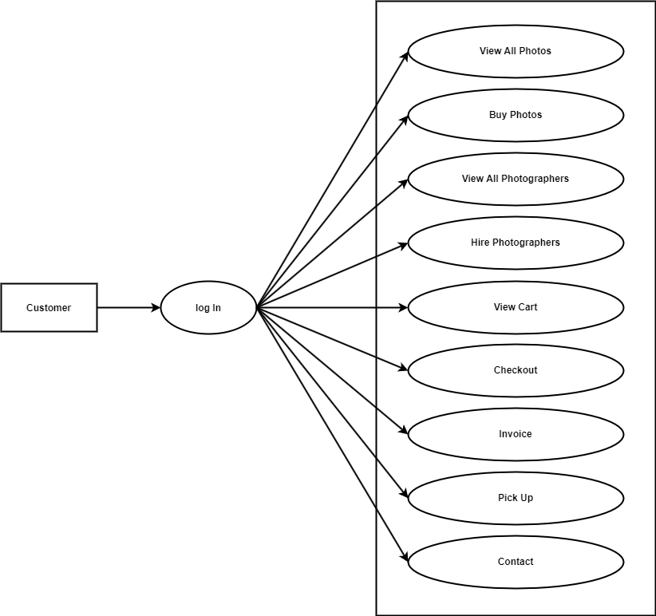

##### Figure 5.4: Use Case Diagram for Customers

##### Use Case Diagram for Photographers:

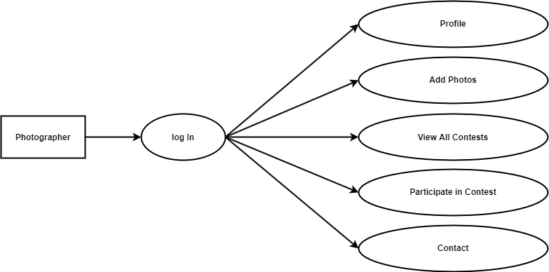

##### Figure 5.5: Use Case Diagram for Admin

##### Use Case Diagram for Admins:

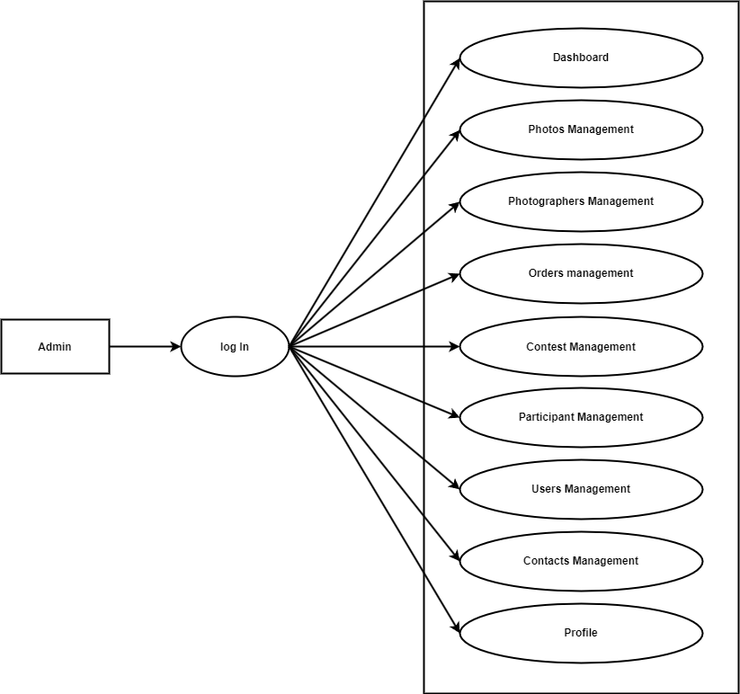

##### Figure 5.6: Use Case Diagram for Admin

##### ER Diagram

An entity-relationship diagram (ERD) is a graphical depiction of an informational system that depicts the relationships between people, things, locations, concepts, and events. An ERD is a data modeling approach that may be used to assist describe workflows and can also be used to build a relational database's basis.

##### 

##### Figure 5.7: ER Diagram

##### Summary

The general project description of the online-based Photography and Photographers Management System was addressed in this chapter. This system contains all of the schematics for all the admin, photographer and customer areas.

**CHAPTER 6**

**SYSTEM IMPLEMENTATION**

Systems implementation refers to a collection of steps taken to finish the design as specified in the authorized system engineering document, as well as test, install, and start using the new or amended Information System. This procedure specifies how the system was or should be developed in order to meet the system's needs.

1. **Log in page**

All users, including admins, customers, and photographers, must sign in with their email address and password. If users enter an invalid email address or password, they will be taken back to the login page. The user will be sent to the admin home page if their role is admin and their email and password match those of their signed-in account. He will be directed to the customer home page if he is playing the part of a customer. The photographer's home page will be displayed if the user is a photographer. The sign-in page can be clicked by anyone who hasn't created an account with the system to do so.

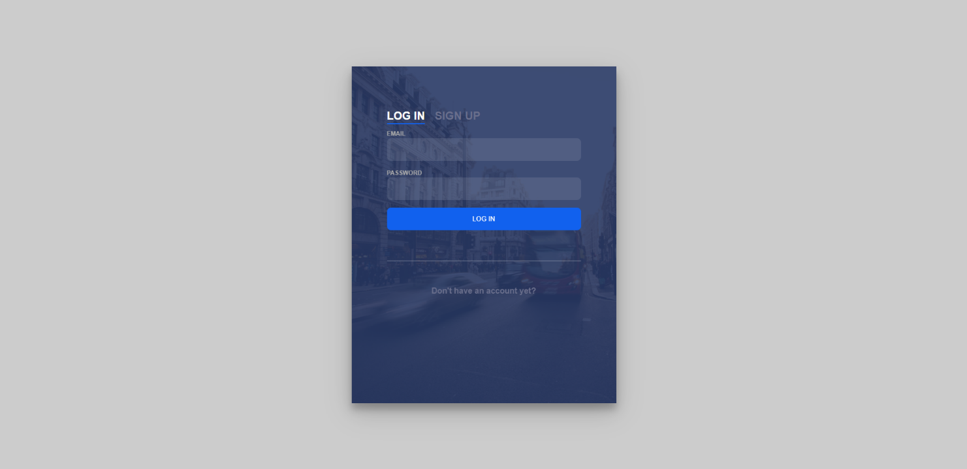

##### Figure 6.1: Log in page

1. **Sign up page**

##### The system allows anybody to sign up as a consumer or photographer even if they don't already have an account. To sign up, they were requested to fill out a form with some basic personal data about themselves. The system administrator will analyze this data when the user provides it to decide whether or not the user is permitted access to the system.

##### 

##### Figure 6.2: Sign up page

1. **Customer**
2. **Customer Home page**

After logging in as a customer, the user will be directed to the customer home page, which provides an overview of the whole customer section. Customers may view all of the photographs that the photographer has made available for purchase on this website. The price and title are visible to them. Customers have the option of searching the images using different tags. They may examine the entire picture, its information, and place an order by clicking on the picture.

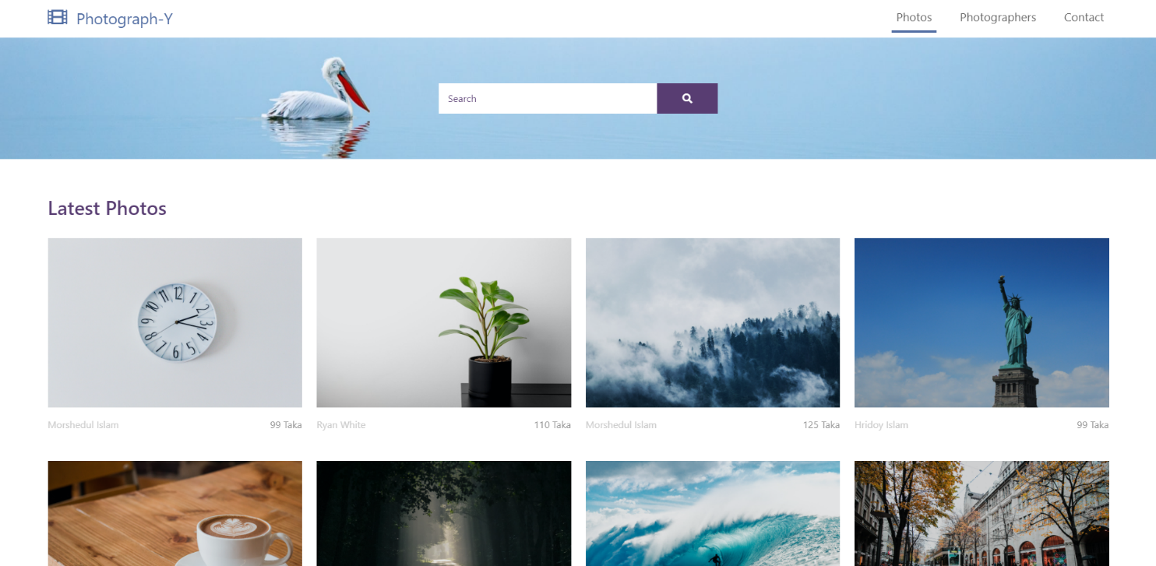

##### Figure 6.3: Customer home page

1. **Photo Details**

Customers may view all the details related to the photo on this page. such as size, format, pricing, and specifics. They may access the photographer's profile information by pressing on the name of the photographer. By clicking the "Buy" button, users may add the image to their virtual cart for later checkout.

##### 

##### Figure 6.4: Photo Details

1. **Photographers**

##### All of the photographers that are accessible through this system are listed here for customers to view. The number of years the photographer has been practicing their talent as well as the types of photography they offer may also be seen. They may obtain a detailed view of the photographer by choosing on their name.

##### 

##### Figure 6.5: Photographers

1. **Photographer Details**

##### On this page, one may see a photographer's in-depth perspective. Here, customers have the option of hiring a photographer. the duration of the photographer's contract, the fee, and the day(s) on which they must be present.

##### 

##### Figure 6.6: Photographer Details

1. **Cart Page**

##### Customers can keep their order on this page until they are ready to check out. All the images and photographers that the client has rented are included on this page.

##### 

##### Figure 6.7: Cart Page

1. **Checkout Page**

##### The consumer submits their credit card information and other data for an online purchase on the checkout page. On the left side of the page, he may see view the products he will be buying. By clicking the "Checkout" button, customers may confirm their order.

##### 

##### Figure 6.8: Checkout Page

1. **Invoice Page**

##### The consumer will receive an invoice after placing an order for photos or photographers and paying for them; they should print this invoice as confirmation of their transaction. On the invoice page, consumers may view the specifics of their order, including the items they bought and the transaction information they provided during checkout.

##### 

##### Figure 6.9: Invoice Page

1. **Pick Up**

##### Customers may find the contact details of the photographer they hired on this page. They can obtain the photographers' phone number and email address. They may contact them immediately by email by clicking the provided email address, and they can even call them by selecting the provided phone number.

##### 

##### Figure 6.10: Pick Up page

1. **Contact Page**

##### Customers can submit messages to the admin via the contact page if they have any suggestions or feedback for them.

##### 

##### Figure 6.11: Contact Page

1. **Photographer**

##### Photographer’s Profile

##### The customer can read the photographer's profile before hiring them if the photographer has completed their profile and nominated themselves on this page. They may select the genre in which they take images, their years of experience, and a profile photo for themselves.

##### 

##### Figure 6.12: Photographer’s Profile

##### Add New Photo

##### Photographers can attach a new image to this page for sale by giving comprehensive information about the image. for instance, the title, details, size, format, and price.

##### 

##### Figure 6.13: Add New Photo

##### Contests

##### On this page, photographers may view all of the contests as well as the number of participants in each contest. They may view more specific contest information by clicking on the contest title.

##### 

##### Figure 6.14: Contests

##### Contest Details

##### A photographer may view all the specific details regarding a contest on this page. such as the specifics of the title, the theme, the entry fee, the prize money, the deadline for submissions, and even the day the results will be announced. Photographers can enter each contest by submitting up to multiple images along with a description of each image.

##### 

##### Figure 6.15: Contest Details

##### Contact Page

##### Photographers can submit messages to the admin via the contact page if they have any suggestions or feedback for them.

##### 

##### Figure 6.16: Contact Page

1. **Admin**
2. **Dashboard**

##### The home page of the Admin UI is the Admin Dashboard. System management is made easier and more comfortable with rapid access to essential Encompass tools. Important system overview information is displayed on the admins dashboard.

##### 

##### Figure 6.17: Dashboard

1. **View All Photos**

##### The admin may view all of the pictures that the photographers have published on this page. If the admin authorizes them, the users will be able to see these photographs. Admin has access to all photo-related data. Since the buyer may obtain the highest-quality photo, he can even delete any photographs that he believes are improper for the system.

##### 

##### Figure 6.18: View All Photos

1. **View All Photographers**

##### The admin can see all of the available photographers on this page. If desired, he may amend any photographer's information, such as whether to approve or disapprove them, and he can also delete any photographer from the system.

##### 

##### Figure 6.19: View All Photographers

1. **View All Orders**

##### Order is a page where the admin may see every order placed by a customer. The admin has access to a number of choices on the page, including authorizing orders and removing orders that customers have abandoned.

##### 

##### Figure 6.20: View All Orders

1. **View All Contests**

##### The admin may view every contest that is currently open on this page. If the admin publishes these contests, photographers will be able to see them. In addition, the admin has more control over the contest, including the ability to remove entries or mark them as drafts so that the photographer cannot see them.

##### 

##### Figure 6.21: View All Contests

1. **Add Contests**

##### The admin can create a new contest by including all the relevant details on this page. Title, description, entrance fee, prize money, submission deadline, and the day the results are supposed to be disclosed are a few examples.

##### 

##### Figure 6.22: Add Contests

1. **Edit Contests**

##### Any contest criteria on this page may be changed by the admin. Changing the submission/result announcement date, changing the title or description, etc.

##### 

##### Figure 6.23: Edit Contest

1. **View All Participants**

##### The admin may view all of the photographers that are taking part in the contests on this page. The admin can access the photos that they have uploaded as part of their contest participation here. He is also capable of making adjustments, such as approving, disapproving, or disqualifying them.

##### 

##### Figure 6.24: View All Participants

1. **View All Users**

##### The admin may inspect every user on the system on this page. The ability to accept or reject user-created accounts belongs to the admin. The administrator may also delete a user from the system.

##### 

##### Figure 6.25: View All Users

1. **View All Messages**

##### Customers' and photographers' messages to the admin that include any kind of information or comments are available to the administrator on this page. Even their erasure is possible if Admin so chooses.

##### 

##### Figure 6.26: Messages

1. **Profile**

##### The profile page is the page where the admin can update his information such as password name email or phone number etc.

##### 

##### Figure 6.28: Profile

1. **Summery**

##### Our system for managing photographers and photography has now been finalized. Our endeavor is dependent upon the authorities' ability to operate efficiently here. It has a very user-friendly user interface. Thus, the Photography and Photographers Management Method is a beautiful and time-saving system as compared to the current manual technique.

**CHAPTER 7**

**TESTING**

##### Introduction

Testing refers to the process of examining and verifying that a system software or program does what it promised to do. This is the process of ensuring that the system is compliant with the specifications and meets the needs of the users. Testing ensures that system programs are error-free, ensuring system end users can successfully interact with the system, and that system interface components are functioning.

##### Functional Testing

Functional testing ensures that the system fulfills all of the functions that were initially stated, as well as that all input is appropriately received. It is system-wide and does not need a technical expertise of the system. All of the system's functions, as initially stated, are thoroughly checked to verify that nothing has been overlooked or misconstrued. An effort is made to forecast errors that an unskilled user could make, and tests are run to guarantee that such errors do not result in improper activities or faulty data being recorded in the database.

##### System Testing

This is when the system is tested to see if it meets the user's needs and functions as expected. The tests to be employed are listed below. After the entire system has been completed, each component is examined to ensure that no faults have been introduced. Although the investigator is not expected to spend days entering multiple entries, the system should be tested with few records in each of the primary tables.

##### Recovery Testing

Recovery testing is a type of software testing that examines a program's capacity to recover from failures such as software/hardware breakdowns, network outages, and so on. The practice of assessing how well an application recovers from crashes, hardware failures, and other challenges is known as recovery testing. Recovery testing can be used to establish what happens if a power outage occurs in the middle of data entry, whether the entire database is damaged, and so on.

##### Test Cases

The goal of test cases is to ensure that the system is functioning properly and in accordance with the established criteria. It entails ensuring that the new system is operational. It's tested in modules to see if there's an issue with any of them. This is where each module is independently tested. While testing, entries should indeed be entered exactly as they are to ensure that they are accepted in the database and that no mistakes are made. If the admin Id should be in digits, for example, the field should not permit character.

##### White Box Testing

White box testing is a software evaluation technique that looks into the product's underlying structure, architecture, code, and inner workings. The program's lines, loops, and logical expressions are all tested in this form of testing.

We performed white box testing in our system to conduct some testing. White Box Testing is typically performed immediately in the stage out process.

##### Black Box Testing

Black box testing is a sort of software testing when the software's functioning is unknown. All conceivable permutations of end-user activities are included in a black box test. Black box testing does not require any programming skills and is used to emulate the end-user experience.

In our system, we employed black-box testing, which looks for faults in the code's outward appearance in the categories listed below.

* Incomplete or incorrect functioning.
* Errors in reasoning
* Errors in data structures utilized by interfaces that cause exceptions.
* Errors in the labeling of grid views.
* Errors in establishment and closure.

##### Missing functionality

It has a functionality issue if everything users want the system to do is challenging, unpleasant, perplexing, or impossible. It's unlikely that we will have the System. According to the requirements of the development, every configuration has been covered. The user must specifically add it because it is not there by default. System may be found in the search box after right-clicking the Resources folder. Customization is available in the net assembly.

##### Error Termination

The action and recovery methods from erroneous situations contained in a software program are referred to as error handling. When a static constructor throws an exception, or when we try to access a class where the static construction manager threw an exception, the Type Initialization Exception is thrown; its Inner Exception asset contains the details of its use that was certainly thrown; this is the exception that we need to start investigating.

**CHAPTER 8**

**CONCLUSION AND FUTURE PLAN**

##### Conclusion

##### In this project, we created a system for managing photographers and photographs that serves as "middlemen" in the photographic industry. It acts as a middleman between the photographers who wish to sell their images for a fee and own the rights to them and the designers and other creatives who require high-quality images fast and affordably.

##### Everybody's life is greatly influenced by photographs since they help us remember our history and remind us of certain people, locations, emotions, and events. They can aid in defining who we are. A photographer's tuning never falters. Because of this, we require photographers. They are the ones that organize the world's mess into pictures that make the chaotic world of existence more understandable. They are the observers and creators that are able to capture the chaos and beauty that surrounds us. Contests are not merely a technique to gain attention or employment; one must really win them in order to achieve that. Additionally, they make it possible to compare one's work to that of other photographers. It provides insight into a photographer's position, talents, and expertise. This may facilitate the provision of photography services to our clients and enable us to identify the top photographic talent.

##### Limitation

##### Each system is constrained in some way. Ours has some as well. Here is a list of a few of them:

##### Admin and customers or photographers don't use a particular channel of communication.

##### The photographers' availability for hire is not constrained to any set schedule.

##### The security of any system needed extensive supervision.

##### The standard can be met in the hereafter by creating an interactive user interface.

##### Future Plan

##### Any business that manages photos and photographers may use the system as their online launch platform by hosting it on a web server. With the aid of this system, a number of sponsors may hold competitions to evaluate the skills of aspiring photographers for further marketing and promotion. An integrated virtual chatting system may be used to facilitate communication between the admin, customers, and photographers. A significant component in the continued promotion of this system might be SEO and affiliate marketing. After the system has been put online, we may use user feedback to develop it with a strong user experience.

**REFERNCES**

[1] W3Schools Free Online Web Tutorials. (n.d.). W3Schools Online Web Tutorials. <https://www.w3schools.com/>.

[2] Contributors, P. (n.d.). PhpMyAdmin. phpMyAdmin. <https://www.phpmyadmin.net/>.

[3] Learn To Code - for Free | Codecademy. (n.d.). Codecademy. <https://www.codecademy.com/>.

[4] Codepen | Social Development Environment. <https://codepen.io/>

[5] Jacob Thornton, And Bootstrap Contributors, M. O. (n.d.). Bootstrap · The Most Popular HTML, CSS, And JS Library In the World. Bootstrap · The most popular HTML, CSS, and JS library in the world. <https://getbootstrap.com/>.

[6] JavaScript.com. (n.d.). JavaScript.com. <https://www.javascript.com/>.

[7] - Js.foundation, J. F. (n.d.). JQuery. jQuery. <https://jquery.com/>.

[8] U. (n.d.). Beautiful Free Images & Pictures | Unsplash. Beautiful Free Images & Pictures | Unsplash. <https://unsplash.com/>.

[9] Font Awesome. (n.d.). Font Awesome. <https://www.fontawesome.com>.

[10] Flowchart Maker & Online Diagram Software. (n.d.). Flowchart Maker & Online Diagram Software. <https://www.draw.io/>.

[11] Google Maps. (n.d.). Google Maps. <https://www.google.com/maps>.

[12] Stack Overflow - Where Developers Learn, Share, & Build Careers. (n.d.). Stack Overflow. <https://www.stackoverflow.com>.

[13] Visual Studio Code - Code Editing. Redefined. (n.d.). Visual Studio Code - Code Editing. Redefined. https://code.visualstudio.com/.